Vocal Toning

Vocal toning is the practice of making sustained vowel sounds with one's voice for therapeutic or meditative purposes. Its roots are thousands of years old. The information below describes the core elements of vocal toning and its associated benefits.

Breath
Toning requires deep breathing, bringing in the prana or life force energy into the body, oxygenating all the body's cells. This positively affects one's physiology in several ways. It removes all the carbon dioxide, increasing the quality of one's blood. Oxygenation of the brain increases clarity of thought. Deep breathing also increases muscle strength and reduces excessive anxiety levels. The movement of the lower and upper diaphragm massages the stomach, small intestine, liver, and pancreas, as well as the heart and improves cellular regeneration. Also, deep rhythmic breathing can change the heart rate, brain waves and one's state of consciousness.

Sound Vibrations in Healing
As the sound vibrates inside your mouth, it is having a profound effect on the body's two most important glands, laying just behind the upper pallet, the pituitary, and pineal glands. The pituitary gland is the master gland, affecting all the others, e.g., gonad, thyroid-stimulating hormone, and cortisol. The pineal gland is considered the center of our spiritual energies. It produces melatonin, a hormone that affects our sleep. It also calcifies with age, possibly contributing to sleep problems as we age. Stimulation to these glands gets the molecules flowing which has biological effects.

Vowel Sounds
Vowel sounds are considered sacred to several cultural groups. The Egyptian culture, for example, has used vowel sound chants extending back to 4000 BC. The Kabbalah, an esoteric school of thought originating in Judaism, consider the vowel sounds to be vibrations of heaven. Don Campbell, an internationally respected sound healer, points out that church Latin has pure vowel sounds and the tone is longer on vowel sounds. Finally, vowel sounds create overtones, to most of us are not audible. However, they have a special healing effect on our body.

Intentionality
Setting an intention is a way to focus one's attention on a way of "being" in the present moment and aligning with it. Setting an intention has the power to direct energy accordingly. With vocal toning, you set an intention. When vocalizing "ah" for example, you can embed the sound with the intention of gratitude, love, world peace, thus creating a healing effect.

Efficiency and Effective
Vocal toning is efficient. All you need is your voice and a chair. When you are ready to start, you are already there. No need for any special equipment or setting.

It is also effective. Self-created sounds increase our oxygen level, lymphatic circulation, melatonin, pain reliever hormones, nitric oxide which releases oxytocin and decreases blood pressure.

Toning the Sounds
Below is an image of the human body demonstrating the location of each of the seven major chakras, their color, and their associated vowel sounds. To begin toning, take a deep belly breath, filling your abdomen and chest cavity. Make the "Uh" sound of the root chakra for seven times. Visualize your chakra happily spinning clockwise as you create each sound. Then, continue toning each chakra all the way up to the crown. Sit with your vibrating body for several minutes and just notice.

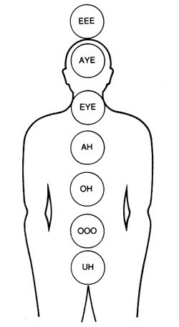

Chakra | Sound
Root | UH" as in huh
Sacral | "000" as in you
Third | "OH" as in go
Fourth | "AH" as in ma
Fifth | "EYE" as in my
Sixth | "AYE" as in may
Crown | "EEE" as in me

Note: The toning practice described above was developed by the renown sound healer, Jonathan Goldman. The image above was reprinted with permission.

